

[Post Trade Standards Working Group]

[OCC Extensions for Large Options Positions Reporting]

[July 20, 2009]

[Revision 0.81]

Proposal Status: GTC voting

DISCLAIMER

THE INFORMATION CONTAINED HEREIN AND THE FINANCIAL INFORMATION EXCHANGE PROTOCOL (COLLECTIVELY, THE "FIX PROTOCOL") ARE PROVIDED "AS IS" AND NO PERSON OR ENTITY ASSOCIATED WITH THE FIX PROTOCOL MAKES ANY REPRESENTATION OR WARRANTY, EXPRESS OR IMPLIED, AS TO THE FIX PROTOCOL (OR THE RESULTS TO BE OBTAINED BY THE USE THEREOF) OR ANY OTHER MATTER AND EACH SUCH PERSON AND ENTITY SPECIFICALLY DISCLAIMS ANY WARRANTY OF ORIGINALITY, ACCURACY, COMPLETENESS, MERCHANTABILITY OR FITNESS FOR A PARTICULAR PURPOSE. SUCH PERSONS AND ENTITIES DO NOT WARRANT THAT THE FIX PROTOCOL WILL CONFORM TO ANY DESCRIPTION THEREOF OR BE FREE OF ERRORS. THE ENTIRE RISK OF ANY USE OF THE FIX PROTOCOL IS ASSUMED BY THE USER.

NO PERSON OR ENTITY ASSOCIATED WITH THE FIX PROTOCOL SHALL HAVE ANY LIABILITY FOR DAMAGES OF ANY KIND ARISING IN ANY MANNER OUT OF OR IN CONNECTION WITH ANY USER'S USE OF (OR ANY INABILITY TO USE) THE FIX PROTOCOL, WHETHER DIRECT, INDIRECT, INCIDENTAL, SPECIAL OR CONSEQUENTIAL (INCLUDING, WITHOUT LIMITATION, LOSS OF DATA, LOSS OF USE, CLAIMS OF THIRD PARTIES OR LOST PROFITS OR REVENUES OR OTHER ECONOMIC LOSS), WHETHER IN TORT (INCLUDING NEGLIGENCE AND STRICT LIABILITY), CONTRACT OR OTHERWISE, WHETHER OR NOT ANY SUCH PERSON OR ENTITY HAS BEEN ADVISED OF, OR OTHERWISE MIGHT HAVE ANTICIPATED THE POSSIBILITY OF, SUCH DAMAGES.

DRAFT OR NOT RATIFIED PROPOSALS (REFER TO PROPOSAL STATUS AND/OR SUBMISSION STATUS ON COVER PAGE) ARE PROVIDED "AS-IS" TO INTERESTED PARTIES FOR DISCUSSION ONLY. PARTIES THAT CHOOSE TO IMPLEMENT THIS DRAFT PROPOSAL DO SO AT THEIR OWN RISK. IT IS A DRAFT DOCUMENT AND MAY BE UPDATED, REPLACED, OR MADE OBSOLETE BY OTHER DOCUMENTS AT ANY TIME. THE FPL GLOBAL TECHNICAL COMMITTEE WILL NOT ALLOW EARLY IMPLEMENTATION TO CONSTRAIN ITS ABILITY TO MAKE CHANGES TO THIS SPECIFICATION PRIOR TO FINAL RELEASE. IT IS INAPPROPRIATE TO USE FPL WORKING DRAFTS AS REFERENCE MATERIAL OR TO CITE THEM AS OTHER THAN “WORKS IN PROGRESS”. THE FPL GLOBAL TECHNICAL COMMITTEE WILL ISSUE, UPON COMPLETION OF REVIEW AND RATIFICATION, AN OFFICIAL STATUS ("APPROVED") TO THE PROPOSAL AND A RELEASE NUMBER.

No proprietary or ownership interest of any kind is granted with respect to the FIX Protocol (or any rights therein).

Copyright 2003-2009 FIX Protocol Limited, all rights reserved

Table of Contents

1 Introduction 5
1.1 Purpose 7
1.2 Change Requirements 7
2 Business Workflow 9
2.1 As-is Workflow 9
2.2 To-Be Workflow 9
3 Issues and Discussion Points 9
4 Proposed Message Flow 10
4.1 Messages 10
4.2 Message Flow 10
4.3 Diagrammed Flows 11
5 FIX message tables 13
5.1 Position Maintenance Request 13
5.2 Position Report 15
5.3 Position Maintenance Report 18
5.4 Registration Instructions 21
6 FIX component blocks 23
6.1 Hedge Instrument Block 23
6.2 PositionQty Block 25
7 Appendix A – Data Dictionary 26
8 Appendix B – Glossary Entries 29
9 Appendix C – Proposed FIXML Abbreviations 29

Document History
Revision | Date | Author | Revision Comments
0.1 | 4/17/2009 | Michael Hemmerling | Initial Draft
0.2 | 4/22/2009 | Michael Hemmerling | Updated for Hanno Klein’s initial email comments
0.3 | 4/27/2009 | Michael Hemmerling | Updated per Jim Northey’s verbal comments
0.4 | 5/13/2009 | Michael Hemmerling | Updated per Jim Northey’s email comments
0.5 | 5/19/2009 | Michael Hemmerling | Added MH responses to Jim Northey’s comments
0.6 | 5/27/2009 | Michael Hemmerling | Per Lisa T.’s suggestions, highlighted changes and  added HedgeInst component to message tables
0.7 | 5/28/2009 | Edited by L. Taikitsadaporn  Additional new functionality by Borys Harmaty | Editted based on discussion on May 28, 2009, GExMC conference call.  Added a version of the HedgeInstrument block as a generic repeating group.  Added additional enum for PositionRequestType and additional descriptive text in Introduction.
0.8 | 5/11/2009 | Edited by L. Taikitsadaporn | Editted based on GTC call on June 11, 2009.
0.81 | 7/20/2009 | Edited by L. Taikitsadaporn | Changed name of "RelatedInstrument" to "RelatedInstrumentGrp" per public comment feedback.

Introduction
“NASD Rule 2860(b)(5) requires member firms to file, or cause to be filed, reports for each account that has an aggregate position of 200 or more options contracts (whether long or short) on the same side of the market covering the same side of the market covering the same underlying security or index. These reports are referred to as LOPRs.” (NASD Notice 05-22 Mar 18, 2005)
Currently, a NASD member firm “may comply with this requirement by filing, or ensuring that another firm files on its behalf, reports to SIAC.” (NASD Notice 05-22 Mar 18, 2005)
Each exchange has a similar rule for large options reporting on file.
The Self Regulatory Organizations (SROs) that receive LOPR information include the seven listed options exchanges and the Financial Industry Regulatory Authority (FINRA). SROs will sometimes be referred to as “the exchanges.”
Since January, 1987, the Securities Industry Automation Corporation (SIAC) has been responsible for the electronic collection and distribution of Large Options Positions Reports (LOPRs) on a daily basis. Processing procedures at SIAC have been relatively unchanged since the system’s inception and several systems enhancements are currently proposed. The Intermarket Surveillance Group (ISG), the main consumer of the daily LOPR output, has asked the Options Clearing Corporation (OCC) to develop and host a new LOPR interface and data repository.
OCC has successfully implemented FIX as its primary means of data communication and has elected to use FIX formats for the LOPR re-write project.
The entities affected by this project include, but may not be limited to:
- Intermarket Surveillance Group (ISG) Participants
  - The Financial Industry Regulatory Authority (FINRA), formed by the consolidation of the NASD and NYSE Regulation
  - NYSE Alternext, formerly American Stock Exchange (AMEX)
  - Chicago Board Options Exchange (CBOE)
  - International Securities Exchange (ISE)
  - NASDAQ Options Market (NOM)
  - NYSE Arca
  - NASDAQ OMX PHLX
  - NASDAQ OMX BX
- OCC Clearing Members
- Non-OCC Clearing Members
- The Options Clearing Corporation (OCC)

NASD Rule 2860(b)(3)(A) imposes a ceiling or position limit on the number of standardized and conventional options contracts in each class on the same side of the market (i.e., aggregating long calls and short puts or long puts and short calls) that can be held or written by a member, a person associated with a member, a customer or a group of customers acting in concert. The Rule provides that the position limits for equity options are determined according to a five-tiered system in which more actively traded stocks with larger public floats are subject to higher position limits. Options exercise limits, which are set forth in NASD Rule 2860(b)(4), incorporate by reference the position limits in NASD Rule 2860(b)(3).

Exchanges have exercise limits on the number of contracts an individual or individuals acting in concert can exercise within 5 consecutive business days.
Exchanges have position limits on the number of contracts an individual or individuals acting in concert may hold at any one time on the same side of the market. ( eg. Given a 5,000 position limit one can be long 3,000 and short 3,000 but can’t be long 5,000 ) Position limits apply to covered and uncovered writes; covered limits are three times as large as uncovered positions.
Note that OTC Collars that meet certain requirements are not required to be reported.
n.b. long side is long calls and short puts together and vice-versa.

Purpose
The purpose of this document is to describe the proposed changes necessary to meet the business requirements of OCC’s LOPR effort.
LOPR is used as a surveillance tool by the Self Regulating Organizations.
OCC plans to utilize existing FIX message types and will require additional enumerations, an additional tag and a new component block.

Change Requirements
OCC is proposing to:

- Create new fields component block to identify RelatedInstrument

  - See component block definition in Section 6.1

- Add a new Position Transaction Type enumeration for:
  - Large Positions Reporting Submission

- Add a new Position Request Type enumeration for:
  - Large Positions Reporting
  - Exercise Position Reporting Submission
  - Position Limit Reporting Submission

- Add new Party Role enumerations for:
  - In Concert Group
  - In Concert Controlling Entity
  - Large Positions Reporting Account

- Add 1328 – Reject Text to the Position Maintenance Report (AM)

- Add 715 – Clearing Business Date to Registration Instructions (o)

- Add Party SubID Type enumerations for:
  - Address City
  - Address State/Province
  - Address Postal Code
  - Address Street
  - Address Country (ISO country code)
  - ISO country code

- Add Party ID Source enumeration for:
  - Tax ID

- Add Position Type enumeration for:
  - Intraday Quantity

- Create a new field in the Position Quantity block called CoveredQty

Business Workflow

As-is Workflow
Currently firms required to report LOPRs send batch files in fixed length file formats to SIAC on a daily basis. Eleven different 80-byte record types are used to submit LOPRs to SIAC. Some firms send every open position that exceeds 200 contracts on a daily basis and others send only updated positions that exceed 200 contracts. This makes for inconsistent reporting among the LOPR firms.
LOPR firms also send In Concert Group information in a single 250-byte fixed length format to the SROs.
SIAC generates a daily snapshot of LOPRs using fixed length formats. The snapshot is transmitted to the SROs using five different 370-byte record types.
SIAC generates reject reports and emails them to email addresses designated by the LOPR firms.

To-Be Workflow
LOPR firms will send LOPR Submissions to OCC only for new, modified or closed positions. Strictly enforced duplicate checking will prevent firms from sending full snapshots of positions exceeding 200 contracts. The Position Maintenance Request will be the message type for LOPR Submissions.
LOPR firms will send In Concert Group information to OCC using the Registration Instruction message type. It is expected that a limited number of firms will utilize this feature.
OCC will send an unsolicited snapshot of all open LOPRs to the SROs on a daily basis using the Position Report.
OCC will send rejected LOPR Submissions back to the submitting LOPR firm using the Position Maintenance Report message type.
OCC will send all rejected and backdated LOPR Submissions for a given day to the SROs using the Position Maintenance Report message type. The SROs need these messages to aid in surveillance and possible investigations.

Issues and Discussion Points

Proposed Message Flow
This flow describes the batch submission of LOPRs and In Concert Groups by LOPR firms to OCC, who in turn updates the LOPR database. OCC provides an unsolicited batch of active LOPRs to the SROs. OCC also sends rejected LOPRs back to the LOPR firms as well as rejected/backdated LOPRs to the SROs.

Messages
Position Maintenance Request (used for LOPR Submissions)
Position Report (used for LOPR Snapshot)
Position Maintenance Report (used for LOPR Rejects and Backdated LOPR Submissions)
Registration Instructions (used for reporting In Concert Groups/Accounts)

Message Flow
LOPR firms send LOPR Submission to OCC to update OCC’s LOPR database
LOPR firms acting In Concert will report In Concert Groups to OCC.
Rejected LOPR submissions are returned to the submitting LOPR firm.
Rejected and backdated LOPR submissions are sent to the SROs.
OCC sends an unsolicited snapshot of all LOPRs on the LOPR database to SROs.

Diagrammed Flows
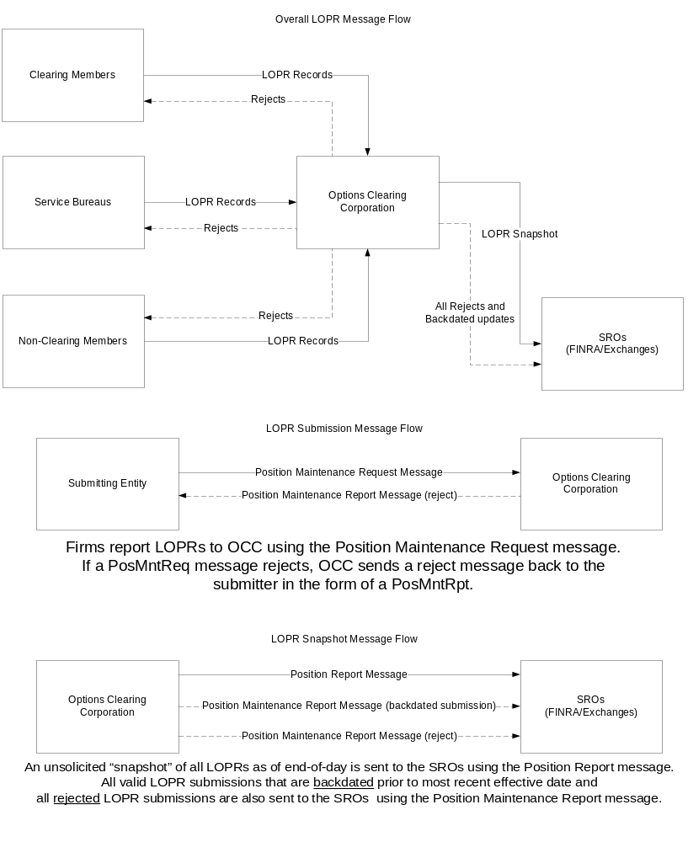

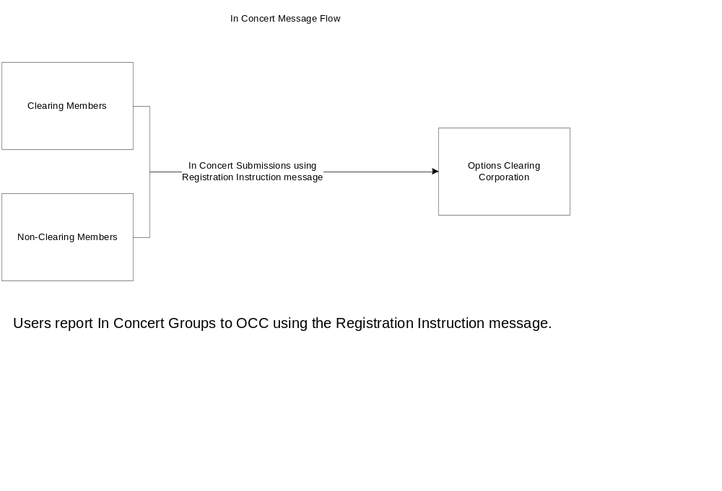

FIX message tables

Position Maintenance Request
Tag | FieldName |  | Req'd | Comments | Action | Mapping Usage and Comments
StandardHeader |  |  | Y | MsgType = AL
710 | PosReqID |  | N | Unique identifier for the position maintenance request as assigned by the submitter. Conditionally required when used in a request/reply scenario (i.e. not required in batch scenario)
709 | PosTransType |  | Y
712 | PosMaintAction |  | Y
713 | OrigPosReqRefID |  | N | Reference to the PosReqID of a previous maintenance request that is being replaced or canceled.
714 | PosMaintRptRefID |  | N | Reference to a PosMaintRptID from a previous Position Maintenance Report that is being replaced or canceled.
715 | ClearingBusinessDate |  | Y | The Clearing Business Date referred to by this maintenance request
716 | SettlSessID |  | N
717 | SettlSessSubID |  | N
component block <Parties> |  |  | Y | The Following PartyRoles can be specified:  ClearingOrganization  Clearing Firm  Position Account
1 | Account |  | N
660 | AcctIDSource |  | N
581 | AccountType |  | N | Type of account associated with the order (Origin)
component block <Instrument> |  |  | Y
15 | Currency |  | N
Start of Component block, expanded in line < InstrmtLegGrp >
555 | NoLegs |  | N | Number of legs
→ | component block <InstrumentLeg> |  | N | Must be provided if Number of legs > 0
End of Component block, expanded in line < InstrmtLegGrp >
component block <RelatedInstrumentGrp> |  |  | N |  | Add
Start of Component block, expanded in line < UndInstrmtGrp >
711 | NoUnderlyings |  | N | Number of underlyings
→ | component block <UnderlyingInstrument> |  | N | Must be provided if Number of underlyings > 0
End of Component block, expanded in line < UndInstrmtGrp >
Start of Component block, expanded in line < TrdgSesGrp >
386 | NoTradingSessions |  | N | Specifies the number of repeating TradingSessionIDs
→ | 336 | TradingSessionID | N | Required if NoTradingSessions is > 0.
→ | 625 | TradingSessionSubID | N
End of Component block, expanded in line < TrdgSesGrp >
60 | TransactTime |  | N | Time this order request was initiated/released by the trader, trading system, or intermediary.
component block <PositionQty> |  |  | Y
component block <PositionAmountData> |  |  | N
718 | AdjustmentType |  | N | Type of adjustment to be applied, used for PCS & PAJ  Delta_plus, Delta_minus, Final, If Adjustment Type is null, the request will be processed as Margin Disposition
719 | ContraryInstructionIndicator |  | N | Boolean - if Y then indicates you are requesting a position maintenance that acting
720 | PriorSpreadIndicator |  | N | Boolean - Y indicates you are requesting rollover of prior day’s spread submissions
834 | ThresholdAmount |  | N
58 | Text |  | N
354 | EncodedTextLen |  | N | Must be set if EncodedText field is specified and must immediately precede it.
355 | EncodedText |  | N | Encoded (non-ASCII characters) representation of the Text field in the encoded format specified via the MessageEncoding field.
120 | SettlCurrency |  | N
StandardTrailer |  |  | Y

Position Report
Tag | FieldName |  | Req'd | Comments | Action | Mapping Usage and Comments
StandardHeader |  |  | Y | MsgType = AP
component block <ApplicationSequenceControl> |  |  | N
721 | PosMaintRptID |  | Y | Unique identifier for this position report
710 | PosReqID |  | N | Unique identifier for the Request for Positions associated with this report. This field should not be provided if the report was sent unsolicited.
724 | PosReqType |  | N
263 | SubscriptionRequestType |  | N | Used to subscribe / unsubscribe for trade capture reports  If the field is absent, the value 0 will be the default
727 | TotalNumPosReports |  | N | Total number of Position Reports being returned
728 | PosReqResult |  | N | Result of a Request for Position
325 | UnsolicitedIndicator |  | N | Set to 'Y' if message is sent as a result of a subscription request or out of band configuration as opposed to a Position Request.
715 | ClearingBusinessDate |  | Y | The Clearing Business Date referred to by this maintenance request
716 | SettlSessID |  | N
717 | SettlSessSubID |  | N
423 | PriceType |  | N
120 | SettlCurrency |  | N
1011 | MessageEventSource |  | N | Used to identify the event or source which gave rise to a message
component block <Parties> |  |  | Y | Position Account
1 | Account |  | N | Account may also be specified through via Parties Block using Party Role 27 which signifies Account
660 | AcctIDSource |  | N
581 | AccountType |  | N | Type of account associated with the order (Origin). Account may also be specified through via Parties Block using Party Role 27 which signifies Account
component block <Instrument> |  |  | N
15 | Currency |  | N
730 | SettlPrice |  | N
731 | SettlPriceType |  | N | Values = Final, Theoretical
734 | PriorSettlPrice |  | N
573 | MatchStatus |  | N | Used to indicate if a Pos Report is matched or unmatched
Start of Component block, expanded in line < InstrmtLegGrp >
555 | NoLegs |  | N | Number of legs
→ | component block <InstrumentLeg> |  | N | Must be provided if Number of legs > 0
End of Component block, expanded in line < InstrmtLegGrp >
component block <RelatedInstrumentGrp> |  |  | N |  | Add
Start of Component block, expanded in line < PosUndInstrmtGrp >
711 | NoUnderlyings |  | N
→ | component block <UnderlyingInstrument> |  | N | Insert here the set of "Underlying Instrument" (underlying symbology) fields defined in "Common Components of Application Messages"  Required if NoUnderlyings > 0
→ | 732 | UnderlyingSettlPrice | N
→ | 733 | UnderlyingSettlPriceType | N | Values = Final, Theoretical
→ | 1037 | UnderlyingDeliveryAmount | N
→ | component block <UnderlyingAmount> |  | N | Insert here the set of "Underlying Amount" fields defined in "Common Components of Application Messages"
End of Component block, expanded in line < PosUndInstrmtGrp >
component block <PositionQty> |  |  | N | Insert here the set of "Position Qty" fields defined in "Common Components of Application Messages"
component block <PositionAmountData> |  |  | N | Insert here the set of "Position Amount Data" fields defined in "Common Components of Application Messages"
506 | RegistStatus |  | N | RegNonRegInd
743 | DeliveryDate |  | N
58 | Text |  | N
354 | EncodedTextLen |  | N | Must be set if EncodedText field is specified and must immediately precede it.
355 | EncodedText |  | N | Encoded (non-ASCII characters) representation of the Text field in the encoded format specified via the MessageEncoding field.
StandardTrailer |  |  | Y

Position Maintenance Report

Tag | FieldName |  | Req'd | Comments | Action | Mapping Usage and Comments
StandardHeader |  |  | Y | MsgType = AM
721 | PosMaintRptID |  | Y | Unique identifier for this position report
709 | PosTransType |  | Y
710 | PosReqID |  | N | Unique identifier for the position maintenance request associated with this report
712 | PosMaintAction |  | Y
713 | OrigPosReqRefID |  | N | Reference to the PosReqID of a previous maintenance request that is being replaced or canceled.
722 | PosMaintStatus |  | Y | Status of Position Maintenance Request
723 | PosMaintResult |  | N
715 | ClearingBusinessDate |  | Y | The Clearing Business Date covered by this request
1328 | RejectText |  | N | Used by CCP to send a reason for rejection | Add | Currently only used in Trade Capture Report and request it be extended to PosMntRpt
716 | SettlSessID |  | N | Intraday(ITD), Regular Trading Hours(EOD),
717 | SettlSessSubID |  | N
component block <Parties> |  |  | N | Position Account
1 | Account |  | N
660 | AcctIDSource |  | N
581 | AccountType |  | N | Type of account associated with the order (Origin)
714 | PosMaintRptRefID |  | N | Reference to a PosMaintRptID (Tag 721) from a previous Position Maintenance Report that is being replaced or canceled
component block <Instrument> |  |  | Y
15 | Currency |  | N
120 | SettlCurrency |  | N
719 | ContraryInstructionIndicator |  | N | Can be set to true when a position maintenance request is being performed contrary to current money position, i.e. for an exercise of an out of the money position or an abandonement (do not exercise ) of an in the money position
720 | PriorSpreadIndicator |  | N
Start of Component block, expanded in line < InstrmtLegGrp >
555 | NoLegs |  | N | Number of legs
→ | component block <InstrumentLeg> |  | N | Must be provided if Number of legs > 0
End of Component block, expanded in line < InstrmtLegGrp >
component block <RelatedInstrumentGrp> |  |  | N |  | Add
Start of Component block, expanded in line < UndInstrmtGrp >
711 | NoUnderlyings |  | N | Number of underlyings
→ | component block <UnderlyingInstrument> |  | N | Must be provided if Number of underlyings > 0
End of Component block, expanded in line < UndInstrmtGrp >
Start of Component block, expanded in line < TrdgSesGrp >
386 | NoTradingSessions |  | N | Specifies the number of repeating TradingSessionIDs
→ | 336 | TradingSessionID | N | Required if NoTradingSessions is > 0.
→ | 625 | TradingSessionSubID | N
End of Component block, expanded in line < TrdgSesGrp >
60 | TransactTime |  | N | Time this order request was initiated/released by the trader, trading system, or intermediary. Conditionally required except when requests for reports are processed in batch, transaction time is not available, or when PosReqID is not present.
component block <PositionQty> |  |  | Y | See definition for Position Quantity in the Proposed Component Block section above
component block <PositionAmountData> |  |  | N | Insert here here the set of "Position Amount Data" fields defined in "Common Components of Application Messages"
718 | AdjustmentType |  | N | Type of adjustment to be applied Delta_plus, Delta_minus, Final. If Adjustment Type is null, the PCS request will be processed as Margin Disposition only
834 | ThresholdAmount |  | N
58 | Text |  | N
354 | EncodedTextLen |  | N | Must be set if EncodedText field is specified and must immediately precede it.
355 | EncodedText |  | N | Encoded (non-ASCII characters) representation of the Text field in the encoded format specified via the MessageEncoding field.
StandardTrailer |  |  | Y

Registration Instructions

Tag | FieldName |  | Req'd | Comments | Action | Mapping Usage and Comments
StandardHeader |  |  | Y | MsgType = o (lowercase O)
513 | RegistID |  | Y
715 | ClearingBusinessDate |  | N |  | Add | Currently not in RegInstr
514 | RegistTransType |  | Y
508 | RegistRefID |  | Y | Required for Cancel and Replace RegistTransType messages
11 | ClOrdID |  | N | Unique identifier of the order as assigned by institution or intermediary to which Registration relates
component block <Parties> |  |  | N | Insert here the set of "Parties" (firm identification) fields defined in "Common Components of Application Messages"
1 | Account |  | N
660 | AcctIDSource |  | N
493 | RegistAcctType |  | N
495 | TaxAdvantageType |  | N
517 | OwnershipType |  | N
Start of Component block, expanded in line < RgstDtlsGrp >
473 | NoRegistDtls |  | N | Number of registration details in this message (number of repeating groups to follow)
→ | 509 | RegistDtls | N | Must be first field in the repeating group
→ | 511 | RegistEmail | N
→ | 474 | MailingDtls | N
→ | 482 | MailingInst | N
→ | component block <NestedParties> |  | N | Insert here the set of "Nested Parties" (firm identification "nested" within additional repeating group) fields defined in "Common Components of Application Messages"  Used for NestedPartyRole=InvestorID
→ | 522 | OwnerType | N
→ | 486 | DateOfBirth | N
→ | 475 | InvestorCountryOfResidence | N
End of Component block, expanded in line < RgstDtlsGrp >
Start of Component block, expanded in line < RgstDistInstGrp >
510 | NoDistribInsts |  | N | Number of Distribution instructions in this message (number of repeating groups to follow)
→ | 477 | DistribPaymentMethod | N | Must be first field in the repeating group if NoDistribInsts > 0.
→ | 512 | DistribPercentage | N
→ | 478 | CashDistribCurr | N
→ | 498 | CashDistribAgentName | N
→ | 499 | CashDistribAgentCode | N
→ | 500 | CashDistribAgentAcctNumber | N
→ | 501 | CashDistribPayRef | N
→ | 502 | CashDistribAgentAcctName | N
End of Component block, expanded in line < RgstDistInstGrp >
StandardTrailer |  |  | Y

FIX component blocks

RelatedInstrumentGrp Component Block
The new RelatedInstrument Block is being proposed to report and differentiate the instrument used as a Hedge versus the instrument being hedged. The latter instrument will appear in the existing Instrument block.

<RelatedInstumentGrp Block>
Tag | Field Name |  | Req'd | Action | Mappings and Usage Comments | Comments
1647 | NoRelatedInstruments |  | N
→ | 1648 | RelatedInstrumentType | N |  | Valid values  1 = hedge instrument | Conditionally required when NoRelatedInstruments > 0
→ | 1649 | RelatedSymbol | N | Add |  | Conditionally required when NoRelatedInstruments > 0. For RelatedInstrumentType = 1 this would be the instrument being used to offset the Option Instrument.
→ | 1650 | RelatedSecurityID | N | Add
→ | 1651 | RelatedSecurityIDSource | N | Add
→ | 1652 | RelatedSecurityType | N | Add |  | Security Type of the related Instrument
→ | 1653 | RelatedMaturityMonthYear | N | Add |  | Expiration Date for the related Instrument contract
</RelatedInstrumentGrp Block>

PositionQty Block
<PositionQty Block>
Tag | Field Name |  | Req'd | Action | Mappings and Usage Comments | Comments
702 | NoPositions |  | N
→ | 703 | PosTyp | N
→ | 704 | LongQty | N
→ | 705 | ShortQty | N
→ | 1654 | CoveredQty | N | Add | Add new field | Short quantity that is considered covered, e.g. used for short option position
→ | 706 | PosQtyStatus | N
→ | 976 | Quantity Date | N
→ | Nested Parties Group
</PositionQty Block>

Appendix A – Data Dictionary

Tag | Field Name | Action | Data type | Description | FIXML Abbreviation | FIXML Schema / XPath Notation
709 | PosTransType | Update | Integer | Identifies the type of position transaction  Valid values:  1 = Exercise  2 = Do Not Exercise  3 = Position Adjustment  4 = Position Change Submission/Margin Disp.  5 = Pledge  6 = Large Trader Submission  7 = Large Positions Reporting Submission | TxnTyp | OCC plans to implement the value  7 for a LOPR submission
724 | PosReqType | Update | Integer | Specifies the type of Position Request being made. Valid values:  0 = Positions  1 = Trades  2 = Exercises  3 = Assignments  4 = Settlement Activity  5 = Backout Message  6 = Delta Positions  7 = Net Position  8 = Large Positions Reporting  9 = Exercise Position Reporting Submission  10 = Position Limit Reporting Submission | ReqTyp | OCC plans to implement the value  7 for a LOPR  WARNING: 7 is already taken
452 | PartyRole | Update | Integer | Identifies the type or role of the PartyID (448) specified. Valid Values:  1=Executing Firm  2=Broker of Credit  …  84=Acceptable Settling Counterparty  85=Unacceptable Settling Counterparty  86=CLS Member Bank  87=In Concert Group  88=In Concert Controlling Entity  89=Large Positions Reporting Account | R | OCC plans to implement the value  86 for In Concert Group  87 for In Concert Controlling Entity  88 for LOPR Account  WARNING: 86 is already taken
1328 | RejectText | Update | String | Identifies the reason for rejection. | RejTxt | Add to Position Maintenance Report message. Description in FIXimate will need to be redefined.
715 | Clearing Business Date | Update | LocalMktDate | Identifies the Business Date | BizDt | Add to Registration Instructions message.
803 | PartySubIDType | Update | Integer | Type of PartySubID (523) value  1=Firm  2=Person  …  32=Execution venue  33=Currency delivery identifier  34=Address City  35=Address State/Province  36=Address Postal Code  37=Address Street  38 = Address Country (ISO country code)  39 = ISO country code | Typ | OCC plans to implement the value of  34 for Account Address City  35 for Account Address State  36 for Account Address Postal Code  37 for Account Address Street
447 | PartyIDSrc | Update | Char | For PartyRole = "InvestorID" and for CIV  7=US Social Security Number  8=US Employer or Tax ID Number  J=Tax ID | Src | OCC plans to implement the value  J for Foreign Tax ID
703 | PosType | Update | String | Used to identify the type of quantity that is being returned.  SOD=Start-of-Day Qty  FIN=End-of-Day Qty  ITD=Intraday Qty | Typ | OCC plans to implement the value  ITD for Intraday Qty
1647 | NoRelatedInstruments | Add | NumInGrp | Number of related instruments |  | Add to the RelatedInstrumentGrpblock
1648 | RelatedInstrumentType | Add | Int | The type of instrument relationship  (need a better description)  Valid values:  1 = "hedges for" instrument | InstrmtTyp | Add to the RelatedInstrumentGrp block  WARNING: Instrument is abbreviated Instrmt
1649 | RelatedSymbol | Add | String | Instrument being used to offset the Option Instrument | Sym | Add to the RelatedInstrumentGrp block
1650 | RelatedSecurityID | Add | String | (same definition as SecurityID) | ID | Add to the RelatedInstrumentGrp block
1651 | RelatedSecurityIDSource | Add | String | (same definition and enum list as SecurityIDSource) | Src | Add to the RelatedInstrumentGrp block
1652 | RelatedSecurityType | Add | String | Security Type of the Related Instrument | SecTyp | Add to the RelatedInstrumentGrp block
1653 | RelatedMaturityMonthYear | Add | MonthYear | Expiration Date for the Related Instrument contract | MMY | Add to the RelatedInstrumentGrp block
1654 | CoveredQty | Add | Qty | Used in the Position Quantity component to describe the portion of the Short Contract Quantity that is considered covered. | CvrdQty | Add to the Position Qty block
RelatedInstrumentGrp block to be added to the following messages:
PositionMaintenanceRequest
PositionReport
PostionMaintenanceReport

Appendix B – Glossary Entries

Term | Definition | Field where used
Hedge | A hedge is used as an offset to an options position, for the purposes of LOPR reporting a hedge will allow an account to have a larger position than the position limit allows. In the context of LOPR, the Hedge is either the underlying stock or future. | [RelatedInstrumentType]
In-Concert Account | All accounts under common control by the same individual(s) or entity must be aggregated to determine position limit compliance. | [PartyRole]

Appendix C – Proposed FIXML Abbreviations
Component / Field | FIXML Abbreviation | Comments
RelatedInstrument | ReltdInstrmt
CoveredQty | CvrdQty | CovQty is not recommended; Cov is currently used to abbreviate Covariance

